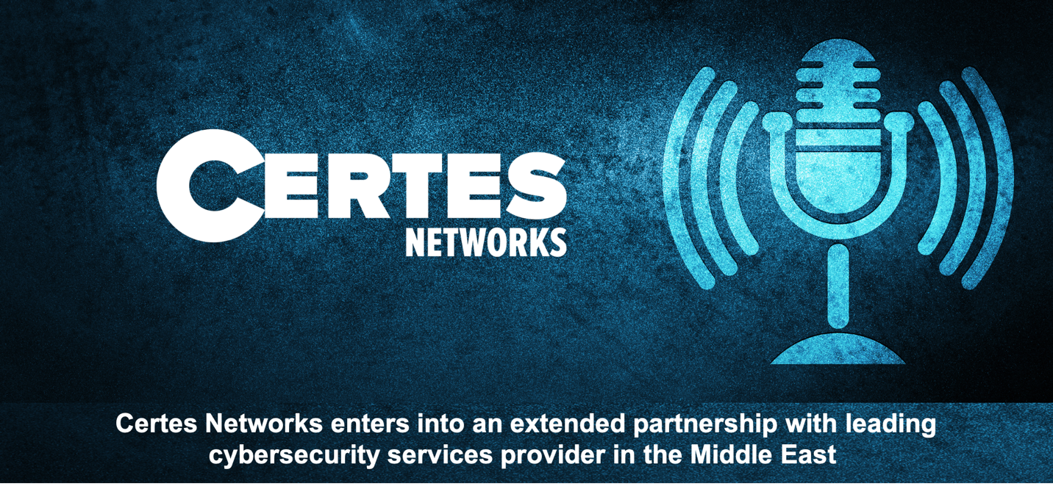
Certes Networks enters into an extended partnership with leading
cybersecurity services provider in the Middle East

17 August, 2020 -- Certes Networks has entered into an extended partnership with Help AG, based on Certes’ long-standing collaboration with UAE’s Etisalat Digital. Etisalat recently announced the completion of the acquisition of Help AG, a regional company specializing in the delivery of cybersecurity solutions and services, establishing Etisalat’s position as one of the region’s strongest cybersecurity companies in the MEA region.

Certes Networks has been partnering with Etisalat Digital for over four years to help provide cybersecurity solutions to its Etisalat customers. Certes Networks Provable Security™ will help to enable Help AG to help its MPLS/SD-WAN customers maintain more control and resiliency over their security posture as organizations move toward a more intelligent, software driven model for the WAN.

“We are excited to extend on the long-term collaboration between Certes Networks and Etisalat Digital as this partnership enables Help AG to offer market leading security solutions in the highly relevant and rapidly growing SD-WAN domain. Certes’ technology strongly complements our portfolio and enables us to round out our cybersecurity offering with a simple solution that ensures maximum data security with less oversight and lower management overhead,” said Stephan Berner, CEO at Help AG.

Certes Networks Provable Security™ is delivered through Certes’ patented Layer 4 technology that addresses many of the data risks encountered not only by end-users, but also by service providers and managed service providers (SP/MSP) when trying to manage and protect the confidentiality and integrity of customer data. One of the many solutions offered through Certes Networks Provable Security is a clear separation of duties allowing governments and enterprise to move to SD-WAN securely and safely. The Certes technology solution offers, for example, crypto-segmentation with automated key rotation which allows customers to maintain the keys while the SP/MSP manages the Certes solution bringing security away from the network.

“The main purpose through our extended partnership with Help AG is to continue to offer groundbreaking cybersecurity solutions to our existing and future customers in the GCC, particularly the United Arab Emirates & the Kingdom of Saudi Arabia. We look forward to further strengthening and developing this partnership towards achieving common goals,” commented Paul German, President & CEO at Certes Networks.

While competitors offer technology solutions that are often disruptive and complex, the Certes Layer 4 solution is an overlay that is network agnostic, easily integrating into any network or transport. Whether MPLS, WAN or SD-WAN, our technology solution is fully interoperable with the existing security stack and with zero impact to performance. This is a significant cost and time savings for customers.

With Etisalat Digital’s acquisition of Help AG, and with Certes Networks technology solution, Etisalat is uniquely positioned to add value to their security portfolio and amplify the cyber security capabilities of their customers.

About Certes Networks
Headquartered in the U.S. with a global presence in Europe, Middle East and Asia Pac, Certes Networks has been delivering security technology solutions to enterprises and governments around the world for over 15 years. Our technology is deployed across 1000 customers in nearly 100 countries and is certified for FIPS 140-2 and Common Criteria EAL4+. Our global foot print of organizations using Certes technology has helped customers to meet national, international or industry-specific regulations.

To learn more about Certes Networks visit www.certesnetworks.com

About Help AG
Help AG, the cybersecurity arm of Etisalat Digital, provides leading enterprise businesses across the Middle East with strategic consultancy combined with tailored information security solutions and services that address their diverse requirements, enabling them to evolve securely with a competitive edge. Help AG has been present in the Middle East since 2004 and is firmly established as the region’s trust IT security advisor. In 2019, Help AG was strategically acquired by Etisalat hence creating a cybersecurity and digital transformation powerhouse in the region.

To learn more about Help AG visit www.helpag.com

# # #

